STUDENT COURSE COMPLETION PREDICTION DATASET

Final Project Documentation in Data Analytics
C301 – 7ANALYTICS

Group Members  (Group 7) | Bulotano, Hana Mae P.  Lobo, Alexander  Reyes, Jael  Tisoy, Glory Ann
Instructor | Ma’am Marsha Superio
Date Submitted | May 15, 2026

General Overview
This project is focused on analyzing student engagement, course performance, and online learning behavior using data analytics techniques and interactive dashboard visualization. The study utilized a real-world dataset containing student information, course details, engagement metrics, and completion records to identify important trends and patterns within an online learning environment.
Overall, the project demonstrated how data analytics and visualization tools helped interpret large datasets, transform raw information into meaningful insights, and support data-driven decision-making in an educational context. The findings provided a clearer understanding of how student engagement influenced course completion and performance, highlighting the importance of consistent participation and effective learning strategies in online education. Through the use of structured data modeling and interactive dashboards, the study made complex data more accessible and easier to interpret for stakeholders such as educators, administrators, and curriculum developers. This enabled them to identify areas for improvement, design targeted interventions, and enhance the overall learning experience.
- Dataset Collection
“Student Course Completion Prediction Dataset”
- Dataset Source
- https://www.kaggle.com/datasets/nisargpatel344/student-course-completion-prediction-dataset

Dataset Description
- As noted by the publisher (NISARG PATEL), this dataset provides detailed information about students enrolled in various online courses. It includes demographic, behavioral, and performance features to predict whether a learner will complete the course or drop out.

Dataset Size
- Total Records: 100,000
- Total Columns: 40
- File Format: CSV

Data Preprocessing

Data Cleaning Procedures Performed
The project followed the CLEAN Framework, as instructed, to ensure the dataset was accurate, consistent, reliable, and ready for analytics and visualization. The CLEAN Framework guided the preprocessing stage by organizing the cleaning procedures into systematic steps.

Conceptualize the Data

The dataset was initially reviewed and analyzed to understand its structure, content, and quality before preprocessing. The techniques used to achieve a clean dataset are the following:
- Asking the right questions.
What does each row represent? | Each row in the dataset represents one student enrolled in an online course along with their demographic information, learning behavior, engagement activity, academic performance, and course completion status.
What are the key metrics? | Key Metrics Used in the Dashboard  - Total Active Students  - Completion Rate  - Dropout Rate  - Total Courses  - Average Progress  - Average Quiz Score  - Average Project Grade  - Average Time Spent  - Average Login Frequency  - Average Session Duration  - Average Satisfaction Rating  - Video Completion Rate  - Enrollment Trend by Month  - Number of Students per Course  - Course Completion Count
What are the key dimensions? | Key Dimensions Used in the Dashboard (Dimension Tables)  - student_dim  - course_dim  - city_dim

- Replacing inconsistent data format using suitable methods
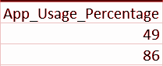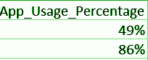
- Validation of corrected entries

Locate Solvable Problems
Duplicate entries were detected and removed to avoid inconsistencies and inaccurate analysis.

Additional solvable problems included:
- Inconsistent formatting
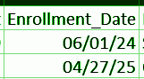
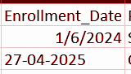
This process improved the consistency and reliability of the dataset.

Evaluate Unsolvable Issues

Certain data limitations and unavoidable inconsistencies were evaluated to minimize their impact on analysis. The dataset underwent several transformations including:
- Data normalization
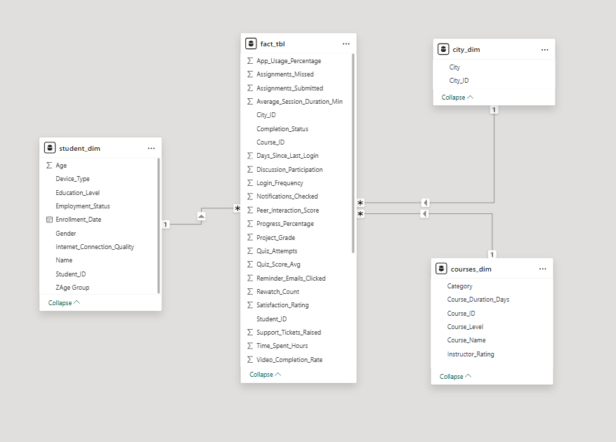

- Converting data types where necessary
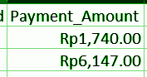
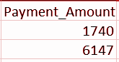

Augment the Data
The cleaned dataset was enhanced and validated to ensure accuracy, consistency, and proper structure for analytics and reporting. This final stage prepared the dataset for exploratory data analysis, KPI generation, dashboard creation, and data-driven insights.
  - Note and Document
Every process is documented.

Exploratory Data Analysis (EDA)
- Summary Statistics Generated
The following statistical measures were generated from the fact_tbl to analyze student performance, engagement, enrollment behavior, and course completion trends within the dashboard.
Measures of Central Tendency | Frequency and Count Measures
Mean Quiz Score | Total Active Students
Mean Project Grade | Total Revenue
Mean Progress Percentage | Total Course Enrollments
Mean Satisfaction Rating | Total Completed Students
Mean Session Duration | Total Non-Completed Students
Mean Login Frequency | Students per Course
Mean Time Spent

Frequency and Count Measures | Percentage and Rate Measures
Distribution of Students by Gender | Completion Rate
Distribution of Students by Employment Status | Dropout Rate
Distribution of Students by Course Level | Video Completion Percentage
Distribution of Students by Device Type
Distribution of Students by Internet Quality
Monthly Enrollment Distribution

ii. KPI and Measures Used
The dashboard utilized several KPIs and analytical measures following the Pyramid
Framework to monitor educational performance and platform engagement.

Strategic KPIs
- Total Active Students
- Completion Rate
- Dropout Rate
- Average Progress
- Average Satisfaction Rating
These KPIs provided high-level insights into platform performance and student success.
iii. Visualizations Used
The dashboard included multiple visualizations such as:
- Bar Charts
- Line Graphs
- Pie Charts
- KPI Cards
- Tables and Matrices
- Slicers and Filters
These visualizations helped simplify the data and improve interpretation.

Data Modeling and Analytics
The project applied data modeling techniques to organize and analyze the dataset efficiently.
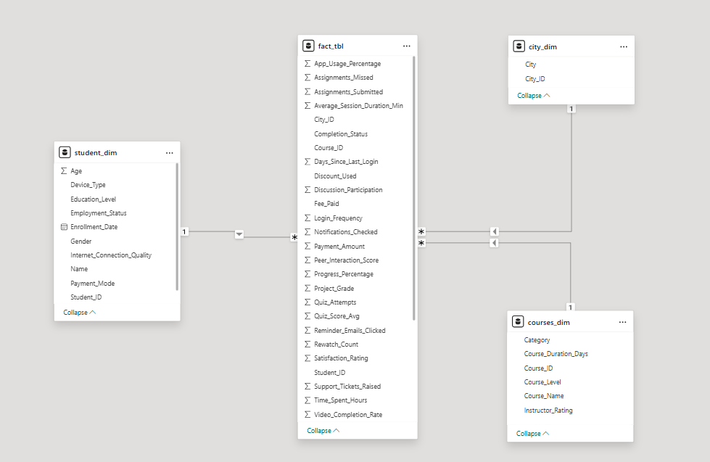
  - Star Schema
Table Name | Table Type | Description
fact_tbl | Fact Table | Stores measurable data related to student performance, engagement, and completion
student_dim | Dimension Table | Contains demographic and behavioral student information
courses_dim | Dimension Table | Stores course-related information
city_dim | Dimension Table | Contains location and geographic information
cleaned_dataset | Source Table | Cleaned source dataset used before modeling

  - Descriptive Analytics
- The project applied Descriptive Analytics to summarize historical data and identify patterns, trends, and relationships within the dataset.

Descriptive Analysis Performed:

Trend Analysis
- Monthly enrollment trends
- Revenue trends
- Student engagement trends
- Completion trends over time

Performance Analysis
- Average quiz scores
- Average project grades
- Course completion performance
- Student progress monitoring

Behavioral Analysis
- Login frequency patterns
- Session duration analysis
- Device usage trends
- Internet quality impact on engagement

Comparative Analysis
- Students by gender
- Students by employment status
- Students by course level
- Students by course category

Visualization and Dashboard
The Dashboard was designed to provide quick access to important metrics, improve decision-making, to present data visually and interactively and simplify interpretation of large datasets. It follows the DASH Framework to guide the design and development.
The dashboard includes:
- Interactive filters and slicers
- KPI cards
- Trend analysis charts
- Dynamic visualizations
- User-friendly interface

The DASH Framework consists of the following components:
D - Decision
The dashboard was designed to support important educational and management decisions related to student engagement, course performance and online learning behaviour.
The dashboard helped stakeholders:
- Monitor student completion and dropout rates.
- Evaluate course performance and effectiveness.
- Analyze trends in enrollment and participation.
A - Audience
The primary audience of the dashboard includes:
- Educators
- Developers
The dashboard was designed to be user-friendly and accessible even for users without advanced analytical knowledge. Clear visualizations, KPI cards, filters, and organized layouts helped users quickly understand and interpret the data.
S - Signal
The dashboard focused on highlighting the most important signals or key indicators that reflect student engagement, learning performance, and platform activity.
The major signals included:
- Total Active Students
- Completion Rate
- Dropout Rate
- Average Progress
- Average Quiz Score
- Average Project Grade
- Average Login Frequency
- Average Session Duration
- Satisfaction Rating
- Enrollment Trends
- Course Completion Trends
These signals helped identify patterns, trends, strengths, and potential problem areas within the online learning platform.

H - Hierarchy
The dashboard followed a clear visual hierarchy to guide users through the information from high-level insights to detailed analysis.
The dashboard structure followed this flow:
- KPI Cards and Summary Metrics
  - Displayed at the top for quick overview and monitoring
- Trend and Comparative Visualizations
  - Included line charts, bar charts, and pie charts to analyze patterns and relationships
- Interactive Filters and Slicers
  - Allowed users to customize and explore the dashboard dynamically
This hierarchical structure improved readability, reduced information overload, and made the dashboard easier to navigate and interpret.

Insights and Recommendations

i. Actionable Insights
Based on the data analyzed in the dashboard, several important patterns and trends were identified regarding student engagement, course performance, and learning behavior.
Insight 1: Students who are more active tend to complete courses more successfully
- The dashboard showed that students with higher login frequency, longer session durations, and more time spent on the platform usually had higher completion rates and better academic performance.
Insight 2: Advanced courses have lower completion rates
- The analysis showed that advanced-level courses had fewer completed students compared to beginner and intermediate courses.
Insight 3: Internet quality affects student performance
- Students with poor internet connection quality generally showed lower engagement, shorter session durations, and lower progress percentages.
Insight 4: Most students use mobile devices for learning
- The dashboard indicated that many students access the platform using mobile phones rather than laptops or tablets.
Insight 5: Students with higher grades are usually more satisfied
- Students who achieved higher quiz scores and project grades also showed higher satisfaction ratings.

ii. Data-Driven Recommendations
Based on the findings from the dashboard, the following recommendations are suggested to improve student engagement and course performance.
Recommendation 1: Encourage students to participate more actively
- The platform can improve student engagement by adding learning reminders, interactive activities, progress tracking features, and reward systems.
Recommendation 2: Provide additional support for difficult courses
- Advanced courses may include extra tutorials, practice activities, simplified explanations, and academic guidance.
Recommendation 3: Improve mobile accessibility
- The learning platform should be optimized for smartphones and tablets.
Recommendation 4: Support students with poor internet connections
- The platform can provide downloadable materials, lower-quality video options, and offline learning support.
Recommendation 5: Monitor student activity regularly
- Teachers and administrators should regularly monitor student progress, login frequency, quiz scores, and completion status.
iii. Real-World Interpretation
The findings suggest that student participation and accessibility greatly affect success in online learning environments. Students who are more active and spend more time engaging with lessons are more likely to complete their courses and perform better academically. The results also show that difficult courses and unstable internet connections can create challenges that may reduce student progress and completion rates. Since many students rely on mobile devices for learning, online platforms should be designed to work efficiently on smartphones and tablets. Overall, the analysis highlights the importance of student engagement, accessible technology, and supportive learning environments in improving academic performance and online learning experiences.

Prepared by:

Bulotano, Hana Mae P.

Lobo, Alexander

Reyes, Jael
Tisoy, Glory Ann
Group 7

Submitted to:

Ma’am Marsha Superio
Instructor, 7Analytics

